## **EDA Analysis of Operating Room Utilization at Assuta Ramat HaHayal (2017–2024)**

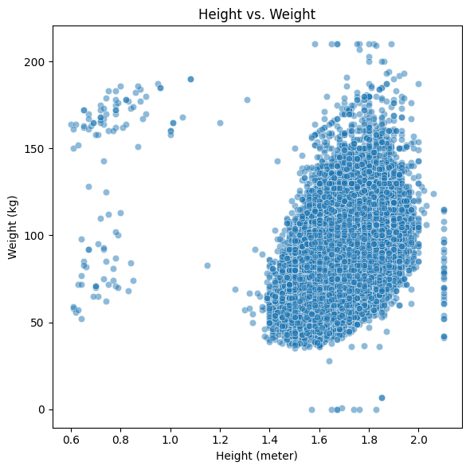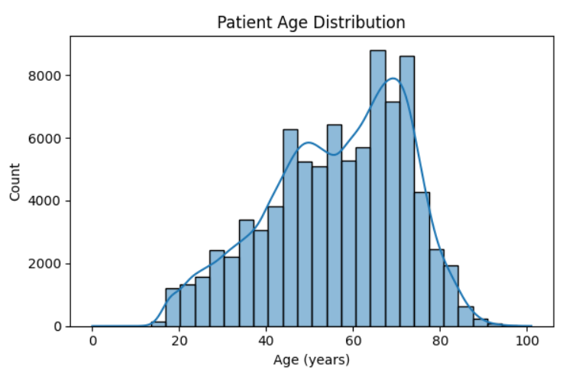

### **Patient Demographics**

**Age Distribution**Our patient cohort is heavily concentrated between 50 and 80 years of age, with a pronounced mode around 65–75. Very few cases involve patients below 20 or above 90. This underscores the importance of adapting perioperative workflows, staffing allocations, and recovery plans to the specific needs of older adults—implementing age-focused anesthesia strategies and postoperative care protocols to reduce complications and improve outcomes.

**Height vs. Weight**The height–weight scatter shows a dense cluster of adult patients around 1.6–1.8 m and 50–100 kg. Outliers appear at the extremes (e.g. pediatric cases, bariatric extremes), but these are rare. Equipment provisioning (operating tables, lifts, anesthesia circuits) and recovery-room logistics should primarily target this core body-size distribution, with contingency protocols for exceptional cases.

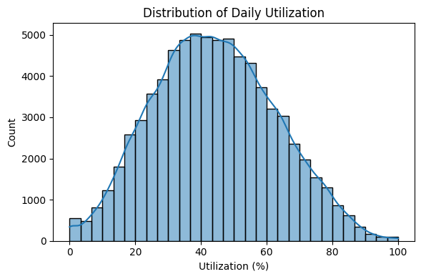

### **Overall Utilization Patterns**

**Distribution of Daily Utilization**Daily operating-room utilization is approximately normally distributed between 20 % and 80 %, with a mean around 50 %. Occasional days show near-zero utilization (public holidays, planned closures) and near-100 %. This mid-range average suggests substantial “white space” in the schedule that could accommodate more cases or ancillary activities (e.g. training, pre-op assessments).

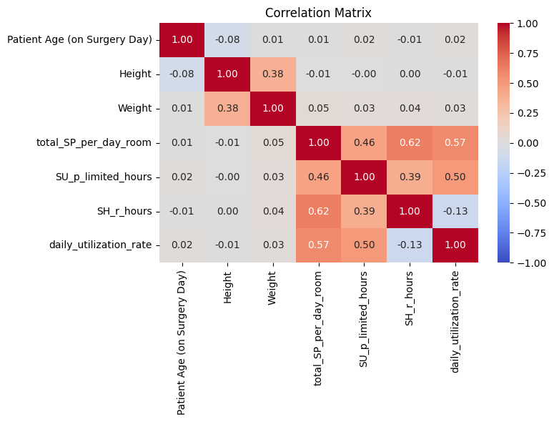

**Drivers of Utilization**

One of the core metrics for evaluating operating‐room efficiency is the **daily utilization rate** ρ\rhoρ, defined as: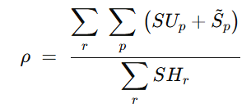

* SUp:​ The **setup** and cleanup time for patients within the room, representing any unplanned or turnover activities that still occupy the room.
* Sp​: The **surgery duration** for patients, **capped** to the block’s shift length so that over-runs beyond​ are not double-counted.
* SHr​: The **total scheduled block time** (shift length) for room rrr on that day.

By structuring utilization this way, we can:

* **Quantify** how much of each block’s scheduled hours were effectively used for actual surgery plus turnover.
* **Prevent** “double-counting” of time when overruns exceed the planned block.
* **Highlight** the relative impact of setup/cleanup versus the core procedure time on overall efficiency.

This formula underpins the correlation analysis and drives our understanding of how scheduling, case mix, and turnover practices contribute to OR performance.

### **Block‐Level Dynamics**

**Scheduled vs. Unscheduled Hours:** Most blocks center around 3–5 h or 10–12 h (half-day vs. full-day sessions). Unscheduled hours cluster tightly near zero—indeed, most days finish on time—but exhibit a long tail up to 5 h overflow. While overruns can boost utilization temporarily, reliance on emergencies to fill schedules undermines predictability and staff well-being.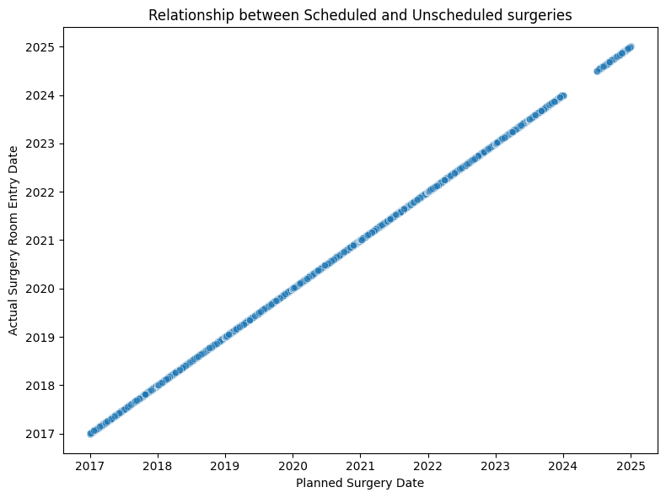

**Planned vs. Actual Entry Dates** A near-perfect 45° alignment between planned surgery dates and actual entry dates confirms that “day‐of‐surgery” scheduling is extremely reliable. Only rare deviations occur, indicating that pre-operative scheduling processes are robust—future efforts should focus more on intra-day efficiency than on macro scheduling accuracy.

**Block Duration Distribution** Operating blocks themselves vary from 2 h clinics to 24 h emergency rooms, with a dominant peak at 8–12 h. Very short and very long blocks coexist; standardizing block lengths (e.g. majority to 8- or 10-h slots) may reduce complexity without sacrificing flexibility.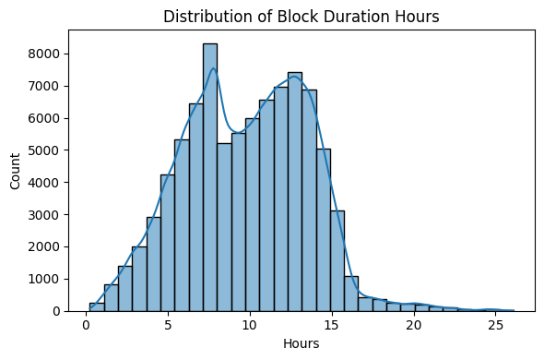

**Utilization by SU Block Category** Across “Small / Medium / Large” block sizes, median utilization holds steady around 40–55 %, but large blocks show heavier upper-tail outliers (occasionally hitting 100 %). This suggests block size alone does not guarantee efficiency—process consistency and case mix management appear equally critical.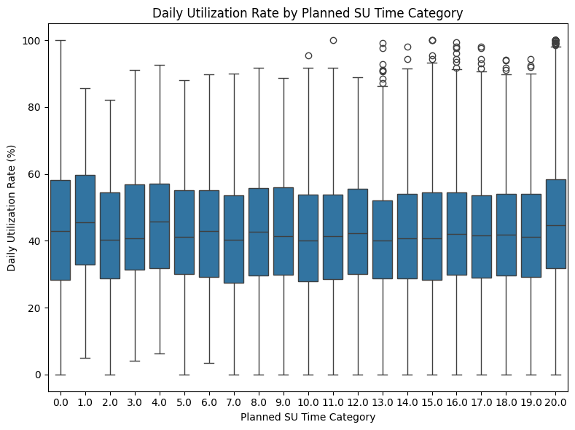

### **Operating‐Room and Team Performance**

**Performance by Room** Average daily utilization by OR reveals a wide spread—from ~19 % in the poorest-performing room to ~53 % in the best. Rooms 20003–20008 consistently exceed 45 %, likely reflecting optimal layout, dedicated staff or favorable case mix. Conversely, rooms 20027–20031 struggle below 30 %, flagging them as prime candidates for process audit (e.g. turnover procedures, cleaning turnaround, equipment availability).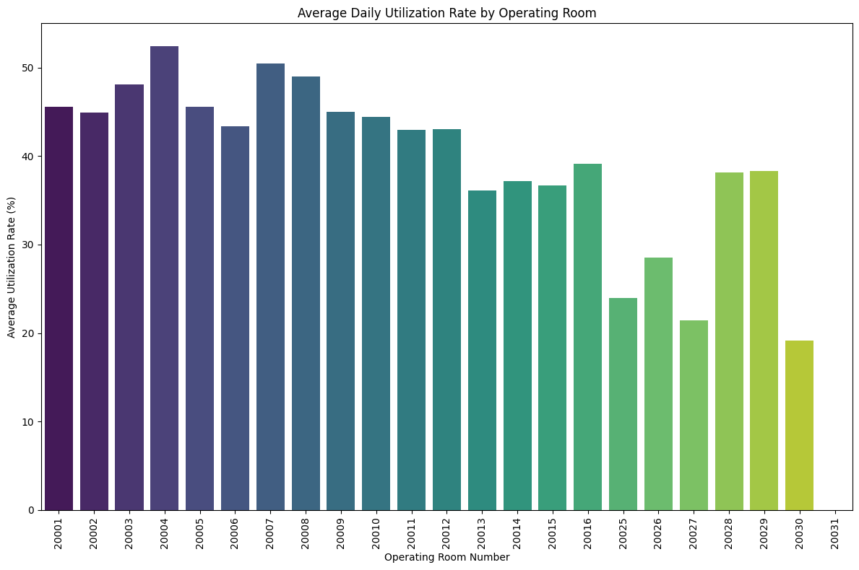

**Surgeon & Anesthesiologist Combinations** The top ten surgeon–anesthesiologist pairs each achieve effectively 100 % utilization—but on very small sample sizes. These extreme values likely reflect one or two high-intensity days rather than sustained performance. Nonetheless, interviewing these teams can reveal “quick-start” or “rapid‐turnover” best practices worth scaling.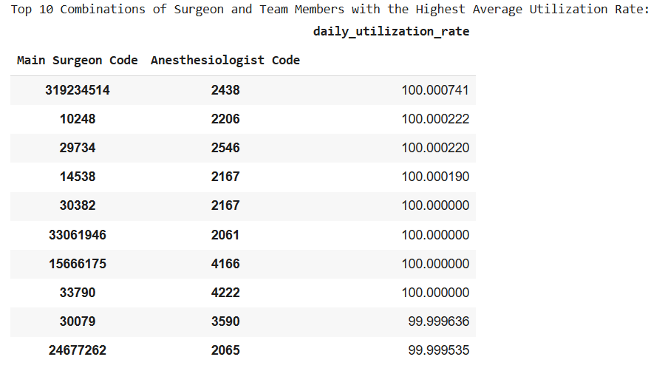

**Top vs. Bottom Surgeons** Separately, ranking surgeons by average utilization shows a handful consistently above ~88 %, while the bottom quintile languishes at 0–5 %. This bifurcation underscores the need to understand individual scheduling habits, cancellation patterns and case complexity—follow-up with low-utilization surgeons may uncover opportunities for centralized scheduling support or cross-coverage.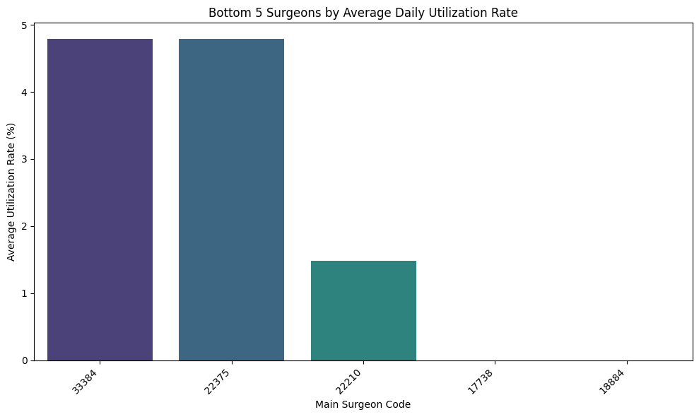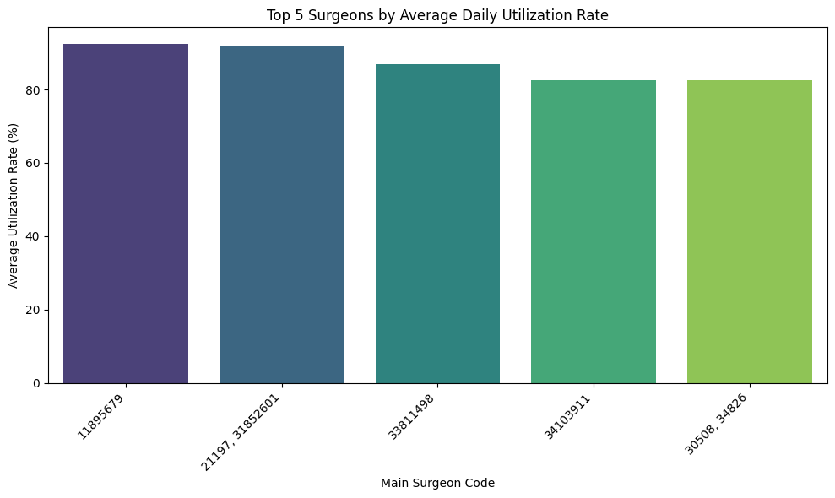

**Conclusion**

Our multi-year analysis reveals a clear path to raising OR utilization from ~50 % toward a target of 70–80 %: blend process standardization (block lengths, turnover), proactive schedule filling (off-peak capacity), and systematic knowledge transfer from the highest-performers. Pair these operational levers with ongoing KPI tracking—both at the room and team levels—and Assuta Ramat HaHayal can significantly boost throughput, staff satisfaction, and patient access without additional physical expansion.